Chandler Unified School District

Extra Curricular Activity Tax Credit Contribution Form

Complete this form and return the completed form with your contribution to: Chandler Unified School District

CIO Tax Credits

1525 W. aye Road

Chandler, AZ 85224



First Name Last Name



Mailing

Address Email Address





|  |  |
| --- | --- |
| If you would like to make a tax credit contribution using a credit card, debit card or e-check, please make your contribution on our secure online system.  To contribute online navigate to:  www.cusd80.com/taxcredit | Cash a Check  a Money Order  Payable to:  Chandler Unified School District  Total Contribution Amount: $ |



direct

my

contribution

needed

a Please direct my contribution to one or more of the following schools (Contributions should equa* the total contribution noted above):

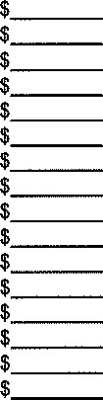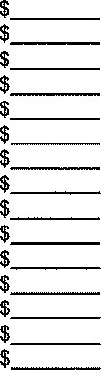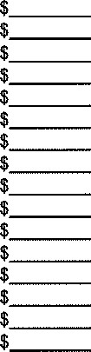Andersen ElementaryCTA - Goodman CampusNavarrete Elementary

Andersen Junior HighCTA - Humphrey CampusPatterson Elementary

Arizona College Prep — ErieCTA - Independence CampusPayne Jr High

Arizona College Prep — OaklandCTA - Liberty CampusPerry High

Auxier ElementaryElite Performance AcademyRice Elementary

Basha ElementaryFrye ElementaryRiggs Elementary

Basha HighFulton ElementaryRyan Elementary

Basha High (AMS)Galveston ElementarySanborn Elementary

Bogle Jr HighHaley ElementarySan Marcos Elementary

Bologna ElementaryHancock ElementarySantan Elementary

Carlson ElementaryHamilton HighSantan Jr High

Casteel HighHartford Sylvia Encinas ElementaryShumway Elementary

Chandler HighHilt AcademyTarwater Elementary

Chandler Early CollegeHull ElementaryWeinberg Gifted Academy

Conley ElementaryJacobson ElementaryWillis Jr High

CTA - Freedom CampusKnox Gifted Academy

|  |
| --- |
| wish to designate this money for (Optional):  General Extracurricular Activities — direct as needed Specific Eligible Activities:  Activity or Grade Level Student First Name Student Last Name |



This contribution is eligible for the Arizona State income tax credit as allowed by ARS § 43-1089.01. Up to $200 per individual and up to $400 for married couples filing jointly can be claimed on personal income taxes. An official receipt will be mailed to the address provided by January 1. Contributions are non-refundable by the Chandler Unified School District. Please consult your personal tax advisor to determine the application of the credit.